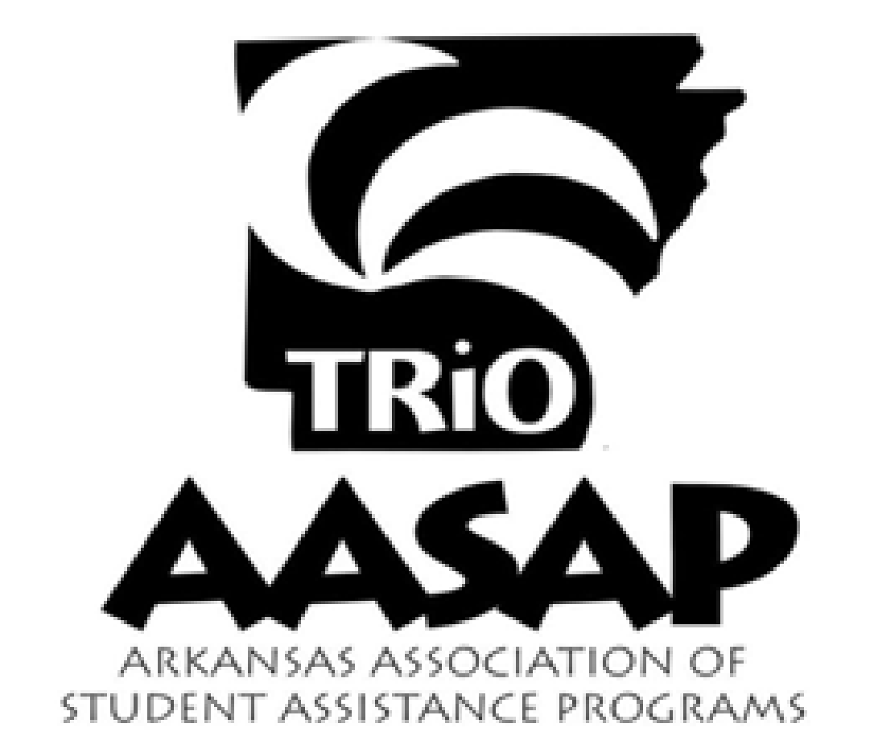
2022 Hall of Fame Nomination Form

Nominee Information
Name:
Address:
Congressional District & Hometown:
Current School/College Attending:
Current School Grade/College Classification:
Major/Career Interest:

I, _________________________________ , give my consent to Arkansas Association of Student Assistance Programs to use, in whole or in part, my name, photographs, videos, and written extractions of the above named person for the purpose of illustrations and publications, including organization/program websites.

_______________________________________________ ______________________
Signature Date

_______________________________________________ ______________________
Parent/Legal Guardian Signature (if nominee under age 18) Date

Nominator Information
Name of AASAP Member:
Institution and Program:
Telephone Number / Email:

Background
The Hall of Fame is an effort to showcase the array of students within Arkansas TRIO Program by noting their various academic and civic accomplishments. Each individual TRIO program can nominate one participant for inclusion in the Hall of Fame booklet. Hall of Fame nominees will be recognized during the Arkansas TRIO Day Program.

Please email completed nomination form, student’s picture, and 300 words or less biography to the AASAP President, president@arkansastrio.org. Please make your selection as soon as possible and submit this form no later than March 31, 2022.

